NAME: K Yamini
REG NO: 192572181

Write a Prolog program to implement Family Tree.
Aim:
To implement a Family Tree in Prolog using facts and rules and to find relationships between family members.
Algorithm:
- Start the program.
- Define facts for male and female members.
- Define parent relationships.
- Define rules for:
Father
Mother
Brother
Sister
- Give a query for a particular relationship.
- Prolog checks the facts and rules.
- Display the matching family relationship.
- Stop the program.
Prolog program:
% EXPERIMENT 23
% Family Tree

% Gender facts
male(ravi).
male(kumar).
male(arun).
female(lakshmi).
female(priya).
female(sneha).

% Parent facts
parent(ravi, priya).
parent(lakshmi, priya).

parent(ravi, arun).
parent(lakshmi, arun).

parent(kumar, sneha).
parent(priya, sneha).

% Father rule
father(X, Y) :-
male(X),
parent(X, Y).

% Mother rule
mother(X, Y) :-
female(X),
parent(X, Y).

% Brother rule
brother(X, Y) :-
male(X),
parent(P, X),
parent(P, Y),
X \= Y.

% Sister rule
sister(X, Y) :-
female(X),
parent(P, X),
parent(P, Y),
X \= Y.
Input:
?- father(ravi, priya).

Output :
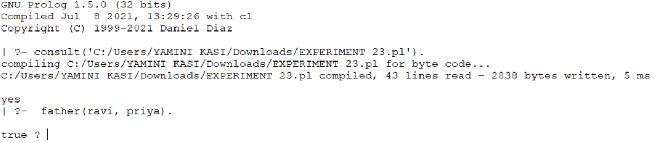
Result:
Thus, the Family Tree was successfully implemented in Prolog using facts, rules, and queries to identify family relationships.

